COMPLETA LA **PROVA INVALSI 2 DI INGLESE,** da pag.28 a pag. 33, ascolta i due brani e completa sulla scheda. Poi riporta le risposte in tabella (puoi completarla direttamente sul computer o stamparla ) e rispediscimela per la correzione ENTRO IL 24 APRILE. Io te la correggerò, la valuterò e ti farò sapere il punteggio ottenuto. Come dico sempre, mettiti in gioco da solo/a, come se fossi in classe. Solo così il risultato ottenuto sarà la misura di ciò che sai fare autonomamente!

**NOME** ............................................................ Data …………………………………………………………

**TASK 1 – MY HOUSE**

|  |  |  |
| --- | --- | --- |
| 0 | There is a shower in the ………… | bathroom |
| 1 | My dad’s car in in the ……… |  |
| 2 | I di my homework in the ……… |  |
| 3 | I can cook in the ……… |  |
| 4 | I can watch TV in the ………… |  |
| 5 | I go to bed in my ……… |  |
| 6 | Mum washes our clothes in the ………… |  |

**TASK 2 – LET’S GO TO THE CIN**EMA

|  |  |  |  |  |
| --- | --- | --- | --- | --- |
|  | | **True** | **False** | **Not given** |
| 0 | It is a film poster. | **X** |  |  |
| 1 | The film is at the Odeon Cinema. |  |  |  |
| 2 | You can go to the cinema on Monday. |  |  |  |
| 3 | On Friday the film starts at 8.00 p.m. |  |  |  |
| 4 | You can watch the film on Tuesday morning |  |  |  |
| 5 | Families can get a discount. |  |  |  |
| 6 | It is an American film. |  |  |  |
| 7 | You can buy something to eat. |  |  |  |

**TASK 3 – CAN YOU READ THESE ROAD SIGNS?**

|  |  |  |  |  |  |  |
| --- | --- | --- | --- | --- | --- | --- |
| **0** | **1** | **2** | **3** | **4** | **5** | **6** |
| **A** |  |  |  |  |  |  |

**TASK 4 – THE BRITISH MUSEUM**

|  |  |  |  |  |  |  |  |
| --- | --- | --- | --- | --- | --- | --- | --- |
| **0** | **1** | **2** | **3** | **4** | **5** | **6** | **7** |
| **B** |  |  |  |  |  |  |  |

**TASK 5 – SALLY’S WARDROBE**

|  |  |  |  |  |
| --- | --- | --- | --- | --- |
|  | | **TRUE** | **FALSE** | **NOT GIVEN** |
| 0 | The email is from Susie. | **X** |  |  |
| 1 | Susie does’t like clothes. |  |  |  |
| 2 | Susie’s got 4 pairs of jeans. |  |  |  |
| 3 | All her t-shirts are pink. |  |  |  |
| 4 | She’s got special clothes for parties. |  |  |  |
| 5 | She wears a shirt when she does arts and crafts. |  |  |  |
| 6 | She’s got 5 jackets. |  |  |  |
| 7 | She’s got 4 jumpers for summer. |  |  |  |

**ASCOLTO 1 – IN A PET SHOP**

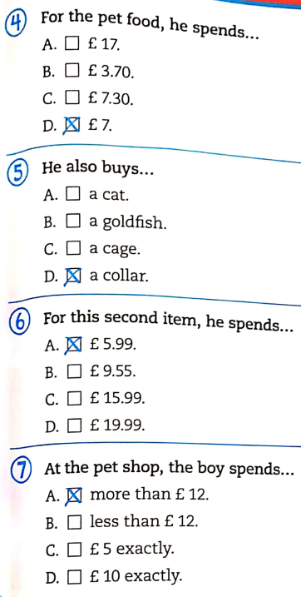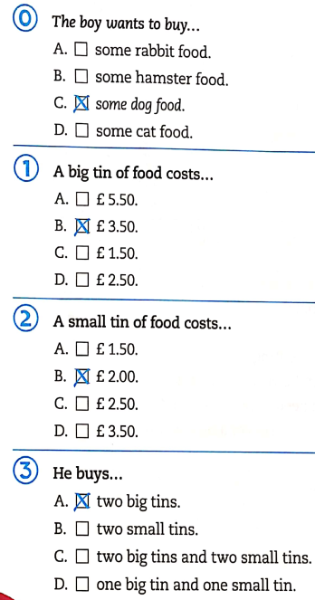Ascolta la conversazione tra un ragazzo e un commesso in un pet shop e segna la risposta corretta.

ORA RIPORTA I RISULTATI IN TABELLA

|  |  |  |  |  |  |  |  |
| --- | --- | --- | --- | --- | --- | --- | --- |
| **0** | **1** | **2** | **3** | **4** | **5** | **6** | **7** |
| **C** |  |  |  |  |  |  |  |

**ASCOLTO 2 – WHAT ARE THEY HAVING FOR LUNCH?**

Ascolta alcune persone che parlano del loro pranzo e inserisci i nomi nelle caselle.

C’è una casella che non ti serve.

Nomi: MERY, PETER, BEN, DEBBY

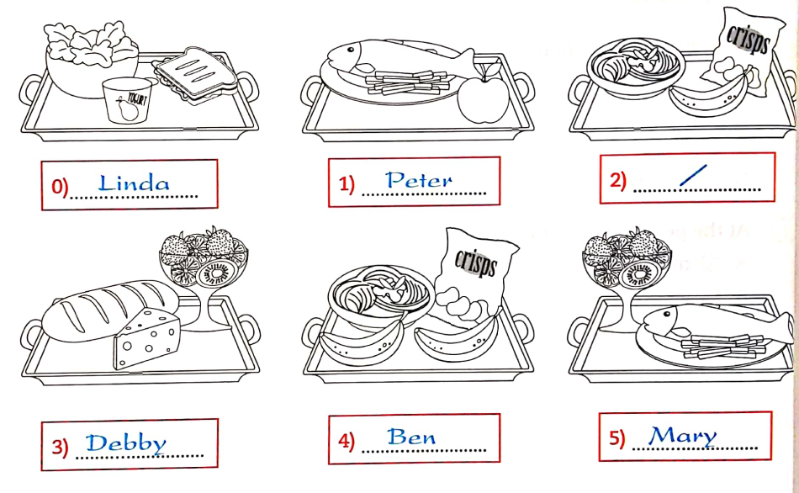

PUNTEGGIO LETTURA: ……………… /33

PUNTEGGIO ASCOLTO: ………………/ 11

TOTALE PUNTI: ………………/44